Jesus, lover of sinners
Reading: from Luke 7:36-50
One of the Pharisees invited Jesus to have dinner with him. There was a woman in that town who had lived a sinful life. She learned that Jesus was eating at the Pharisees house. So she came there with a special jar of perfume. She stood behind Jesus and cried at his feet. And she began to wet his feet with her tears. Then she wiped them with her hair. She kissed them and poured perfume over them.
The Pharisee who had invited Jesus saw this. He said to himself, “If this man were a prophet he would know who is touching him. He would know what kind of woman she is. She is a sinner!”
Jesus said to the Pharisee, “Do you see this woman? I came into your house. You did not give me any water to wash my feet. But she wet my feet with her tears and wiped them with her hair. You did not give me a kiss. But this woman has not stopped kissing my feet. You did not put any olive oil on my head. But she has poured this perfume on my feet. So I tell you this. Her many sins have been forgiven.”
Thought about the reading
The Pharisee in the reading was an important leader like a vicar in a church. He thought he was a good person. He would not go near someone like the woman. She had done lots of wrong things. He thought she was unclean. If he went near her, she might make him unclean as well.
Jesus was not worried about the woman’s sins. He saw that she was sorry for what she had done. That was why she poured the perfume on his feet. She knew that Jesus loved her and was able to forgive her.
Jesus loves each of us. It does not matter what we have done wrong in the past. It does not matter if we have made a mess of things. It does not matter what other people think of us. Jesus loves us, and if we tell him we are sorry, he will forgive us.

Prayer
Dear Jesus, thank you that you love me no matter what things I have done wrong. I am sorry and I ask you to forgive me.
Please help me to live as you want me to.
Amen

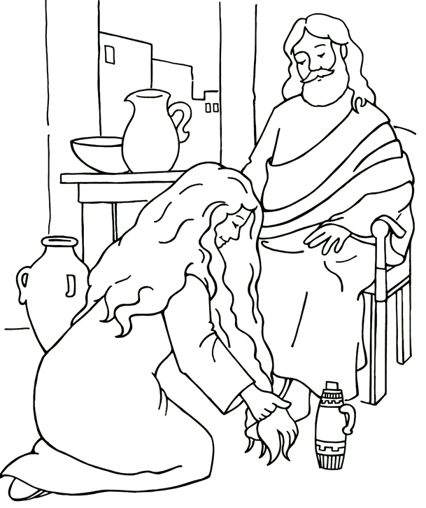

Cambridge Causeway

Autumn 2025
Bible Study notes

Jesus the reason
2. Jesus, Lover of sinners
By Chrissy Cole

